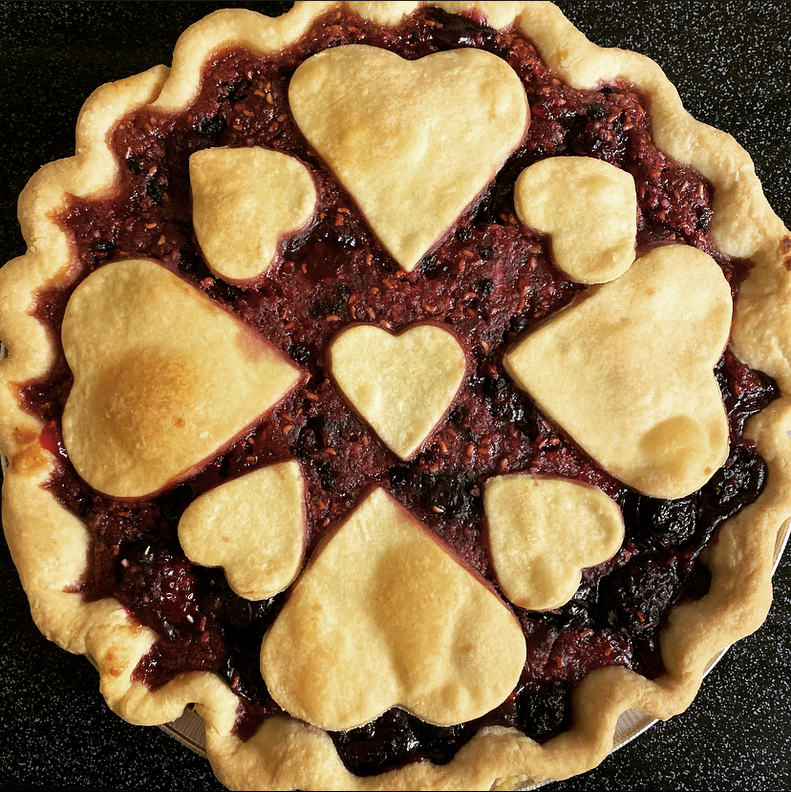
#threeforkspielady pie order form
ALL pie orders require a one week (7 days) advanced notice and
must be paid for in advance
Order date: ______________________________________________________________
Pick up date: _____________________________________________________________
Customer Name: _________________________________________________________
Order taken by: __________________________________________________________
Pie Flavors, All Pies are $37
(Circle pie(s) being ordered, and crust selection)

Dutch Apple
Apple Crisp
Double Crust Apple
Apple Blackberry
Apple Raspberry
Apple Cherry
Double Crust Tripleberry
Tripleberry Crumble
Baked Raspberry
Raspberry Sour Cream Crumble
Fresh Raspberry
Blueberry
($45) Double Crust Huckleberry (Seasonal)
Blueberry Crumble
Raspberry Blueberry
Raspberry Blackberry
Cherry Almond Crisp
Double Crust Double Cherry
Black Forest Cherry
Baked Peach
Peach Sour Cream
Maple Bourbon Peach Crumble
Fresh Peach (Seasonal)
Strawberry Rhubarb (Seasonal)
Fresh Strawberry
Strawberry Cream
Butterfinger Cream
Peanut Butter Reese’s
Peanut Butter Crème
Oreo Cream
Mint Oreo Cream
Triple Chocolate Brownie
Mint Chocolate Brownie

Caramel Pecan Cheesecake (Graham cracker crust)
Strawberry Cheesecake (Graham cracker crust)
Red Berry Cheesecake (Graham cracker crust)

Tripleberry Cheesecake (Graham cracker crust)
Pumpkin Cheesecake (Graham cracker crust)
($45) Huckleberry Cheesecake
(Graham cracker crust) (Seasonal)

Pumpkin
Pumpkin Pecan
Pumpkin Chocolate Chip
Bourbon Pecan *Local Favorite
Espresso Pecan
Maple Pecan
Southern Pecan
Coconut Pecan
Chocolate Pecan
German Chocolate “cake” pie
Old fashion Banana Cream
Coconut Cream Custard
Boston Cream Pie
Chocolate Smore
Amish Oatmeal
Butterscotch Oatmeal
Oatmeal Chocolate chip

Meyer Lemon (Graham cracker crust)
Lemon Cream (Graham cracker crust)
Double Cream Lemon (Graham cracker crust)
Strawberry Lemonade (Graham cracker crust)
Raspberry Lemonade (Graham cracker crust)
Key Lime (Graham cracker crust)
Lime Cream (Graham cracker crust)
Strawberry Limeade (Graham cracker crust)
Key Lime Raspberry (Graham cracker crust)
Blueberry Lemon Cream (Graham cracker crust)
($47) Huckleberry Lemonade
(Graham cracker crust) (Seasonal)
*(Sugar Free & Gluten Free options also available, please ask to verify flavors) *sf & *gf pies $47
Other pie flavor request: (ALL special requests must be cleared by the Pie Lady before ordering)

__________________________________________________________________________________________
Total price: ____ x Number of pies ordered: ___________ = Total: _____________________________

Customer Signature:_________________________________________________________________________
Customer Phone number: __________________________________________________________________________
THANK YOU FOR YOUR ORDER! The #threeforkspielady Version: 01/2022

